 | John Smith
 | PROFILE
 | Nulla sed mi at arcu fermentum rutrum eget quis neque. Lorem ipsum dolor sit
 | EDUCATION
 | 2007-2010 |  | The Master of Business Administration (MBA) |  |  | Sample University
 |  |  | Nulla sed mi at arcu fermentum rutrum eget quis neque.
 | 2003-2007 |  | Bachelor of Arts (BA) |  |  | Sample University
 | EXPERIENCE
 | 2012-Present |  | Company Name # 1 |  |  | Position
 |  |  | Nulla sed mi at arcu fermentum rutrum eget quis neque.
 | 2010-2012 |  | Company Name # 2 |  |  | Position
 |  |  | Lorem ipsum dolor sit amet, consectetur adipiscing elit.
 | PROFESSIONAL SKILLS
- Lorem ipsum dolor sit amet
- Consectetur adipiscing elit
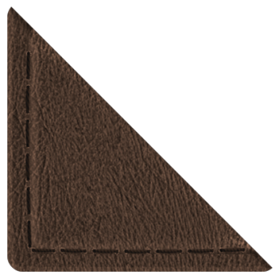
 | PERSONAL SKILLS
- Lorem ipsum dolor sit amet
- Consectetur adipiscing elit
 | CONTACT DETAILS
 | Address: | 123 Pretty Lane, Beautiful County, NY 1267
 | Phone: | 123-456-78-90
 | Email: | john@example.com

